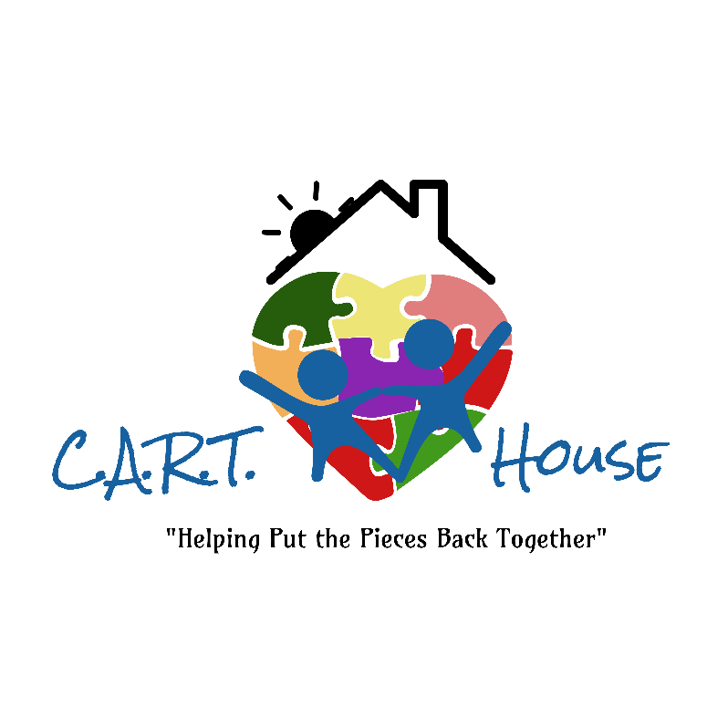
VOLUNTEER PACKET

VOLUNTEER PACKET
Our History
The C.A.R.T. House is an inspiring example of a successful public/private partnership. In 1990, a group of concerned citizens of Canadian County were determined to improve services to children victimized by child abuse and neglect. The Citizen’s Advisory Board was therefore established, with members being from different towns in Canadian County. The board became incorporated, and tax exempt status was accomplished in 1992. The C.A.R.T. House is to provide the children that have been sexually and physically abused with a child-friendly and safe environment where they can be interviewed. The best advantage is that children only have to be interviewed once opposed to telling their story multiple times to multiple entities.

The CAC’s Mission Statement: To improve the way professionals identify, investigate, prosecute, and treat victims of child abuse and neglect; committing ourselves to teamwork and dedicated to reducing a child’s trauma.

The CAC is dedicated to:
- Ensuring that victims of child abuse and their non-offending family members have access to support and services in a safe, compassionate, and respectful environment.
- Helping obtain timely and appropriate services to children in cases of alleged child abuse. Services may include: forensic interviewing, assistance by law enforcement, social services, medical help, and counseling professionals.
- Working to prevent child abuse through education and social acknowledgement that child abuse is a problem in all communities.
- Serving as an informational source for those unsure of how to report child abuse.
- Acting as an educational resource to the community about child abuse.

Programs
Family Support Services: The family support program provides services to non-offending caregivers of children interviewed at The C.A.R.T. House. A Child/Family Advocate will talk with the non-offending caregiver while their child is being interviewed. The advocate can provide a range of services, such as counseling intervention, community referrals, medical exams, and victim’s compensation education.

Forensic Interview: A forensic interview is a structured conversation with a highly qualified interviewer who is specifically trained to talk to children when there have been suspicions or allegations of abuse or trauma. A multidisciplinary team of professionals watches the interview from a separate room to determine how to best keep the child and community safe. The interview is recorded and used by investigators as part of the criminal prosecution.

Medical Examinations: We recommend that all children who may have been abused receive a medical examination by a pediatric SANE exam nurse. The exam ensures the health and well-being of child victims and helps answer questions may have about their bodies. The pediatrician will also document any significant forensic findings.

Volunteer Opportunities
Fundraising- (Hours vary) Volunteers may be responsible for coordinating fundraising events, or researching and developing grant applications depending on the interests and skill set of the volunteer.

Victim Advocate- (10-30 hrs/wk) Volunteers may be responsible for answering phones, scheduling interviews, creating family resource folders, assisting with administrative tasks, entering case files, organizing the desk area and play room, replenishing snacks and drinks, and supervising children as needed. Relevant background in childhood development and current affiliation with a University is required.

Maintenance- (Hours vary) Volunteers will be responsible for small projects around the house or property that need attention in order to keep our houses comfortable and warm for our families, and our yard enjoyable, family friendly, and safe for children.

Special Events- (Hours vary) Volunteers who would like to be contacted when an event needs to be staffed or for other irregular tasks that are necessary to support the center.

Becoming a CAC Volunteer
Volunteer Applications will be reviewed by the Director and CAC staff. Selected applicants will be asked to interview. Due to the nature of our work, volunteers must pass a background check and sign a confidentiality agreement prior to beginning at the CAC. Volunteers will be given a tour of the center and receive a brief orientation. Select trainings may be necessary depending on the nature of the volunteer’s position. If you are interested in volunteering with the CAC, please submit an application.

The CAC’s Equal Opportunity Statement:
The C.A.R.T. House follows an equal opportunity employment policy. No person shall be excluded from participation in, be denied benefits of or be otherwise subject to discrimination under any program or activity for reasons of race, creed, color, ethnicity, national origin, religion, sex, sexual orientation, gender expression, age, physical or mental ability, veteran status, military obligation, and/or marital status. This statement applies to all individuals who conduct services or receive services with the CAC including, but not limited to staff, team members, board members, volunteers, and clients.

